Name ______________________________ Homework April 17-21
Module 8 Week 2

Put your initials by each night that your child practiced the following:
____Monday ____Tuesday ____Thursday
*Nightly Homework*
1. Read Start Right Reader page.
2. Count numbers 1-100.
3. Practice assigned Sight Word list in red reading folder.

Monday: Read each word. Add an e to the end and draw a picture of the new word.

bon__ rob__ hom__ cub__ mul__

cup | pet | pin | dad | got | sit | ham | vet | cop
_____ | _____ | _____ | _____ | _____ | _____ | _____ | _____ | _____
_____ | _____ | _____ | _____ | _____ | _____ | _____ | _____ | _____
_____ | _____ | _____ | _____ | _____ | _____ | _____ | _____ | _____
Tuesday: Write each spelling word three times.

Circle the ending sound for each picture.

boat  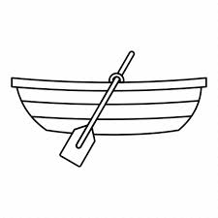  b s t | cake  k m t | bone  s n b | soap  s h p

Thursday: Color the picture and write 2 sentences about it.

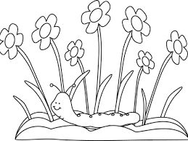

_____________________________________________________________

_____________________________________________________________

_____________________________________________________________

Words to Know

home like many right ride

Big Stones
“I like this home. It is cute!” states Hen. Mule nods. Then Mule steps out. He slips on a stone. Wham! “Too many stones in this lane! We must get rid of them right now, Hen.” Hen and Mule stack stones. Cat and Dog ride past. “Hen! Mule! We can help!” Cat picks up stones. Hen stacks them. Mule and Dog tug big stones with ropes. Then the pals ate and made jokes. “Hen, I like this home!”

Talk about the story and answer the questions:
Who are the characters in the story? What does Hen say about her new home? What happens when Mule steps out? What is wrong with the lane? Who offers to help? How do they move the big stones? What do the pals do after they move the big stones?

